 ** 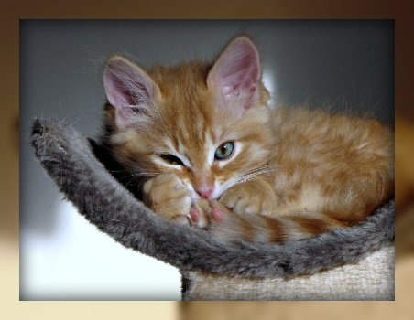 The TNR is a Trap Neuter Release Program.**

**We have a stray cat issue in Blanchard. This program will help with removing the sick, and spaying or neutering the healthy ones. The cats will be evaluated when trapped. If they are sick they will be euthanized. If the cat is feral it will be spayed or neutered, vaccinated, ear tipped and released in the area it was trapped in. The ear tipping will allow us to know if the cat has already been altered. If healthy and tame, after stray hold of 3 days without a micro-chip and 5 days with a micro-chip, they will be put up for adoption after being spayed or neutered, vaccinated, and ear tipped. There will be a charge for owner to claim their cat, the charge is to reimburse Sweet Paws Rescue to cover the medical expense. The city is waving the adoption fees from October 17 to November 23, 2022. Sweet Paws Rescue will be financially supporting this program by donations to cover the expense of treatments. There will no city funds used in the program. Please assist us by donating to the program: there are collection cans in several of our local retailers and you can donate at Liberty Bank in Blanchard to Sweet Paws Rescue Foundation. All the money donated will be kept in Blanchard and support the TNR Program for the City of Blanchard stray cats.**

  